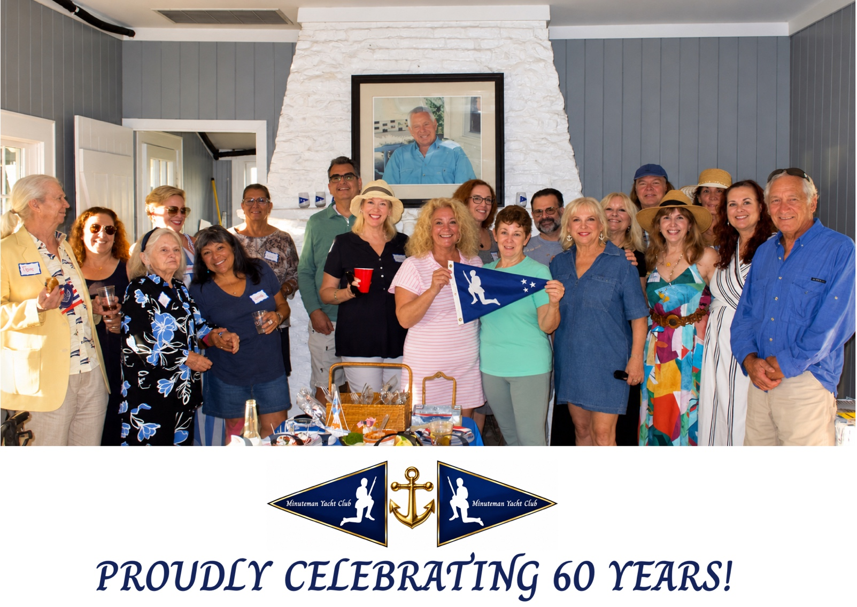

ARTICLE WRITTEN BY JEREMIAH REYES

The Archive

The Minute Man
On the evening of April 25, 1777, roughly two thousand British troops under General William Tryon landed at Compo Beach and marched inland to Danbury, where they burned a Continental Army munitions depot. Marching back to their ships three days later, on April 28, they met colonial militia, ordinary farmers and tradesmen trained to muster on a minute's notice, in the Battle of Compo Hill. Twenty colonial fighters were killed and forty to eighty wounded, in fighting it was reported was fiercer than Lexington or Concord.
The statue that lent our club its name, sculpted by Westport artist H. Daniel Webster and dedicated in 1910, still kneels at the intersection of Compo Road South and Compo Beach Road, close by where some of those militiamen are buried, and a short walk from our own clubhouse. It has been Westport's own emblem ever since: on the town's 1935 centennial, on the town flag adopted in 1986, and, for one afternoon in 1957, on I Love Lucy.

The Founding

Sixty Years at the Ned Dimes Clubhouse
Minuteman Yacht Club is marking its sixtieth year in 2026, though the clubhouse it calls home is older still. Cedar Point Yacht Club held the building from 1932, when it moved into the Compo Basin, until 1966, when it relocated to Bluff Point at the eastern end of Saugatuck Shores. The clubhouse it left behind, now known as the Ned Dimes Marina Clubhouse and owned by the Town of Westport, became home to a newly organized club that took its name from Westport's own Revolutionary War militia: Minuteman.
Six decades on, the clubhouse still anchors the club's calendar, from Commissioning Day each June to the Change of Watch each November. Membership has grown well beyond its boating-club beginnings, but the address has never changed.

Just Offshore

The Island They Saved
A few miles off Compo Beach sits Cockenoe Island, twenty-odd acres of sand, scrub, and nesting shorebirds. In 1967, the power company that had bought the island announced plans to build a nuclear plant there: fourteen stories tall, connected to the mainland by a causeway. Westport residents organized against it, gathering photographs of families picnicking and swimming on the island and sending them to state legislators and the press.
In March 1969, hundreds of Westport residents traveled to the State Capitol to support a bill giving towns priority over utility companies in cases like this one. The power company called Westport's town attorney almost immediately after, offering to sell. The town bought the island and set it aside as open space, a victory Life magazine's Fourth of July issue in 1970 called "one of the most significant conservation victories in the nation." It is still open space today, and still where the club's own boats headed for a Drop Anchor outing this August.

